Lab 1 Create a Disk Partition

Alex Arnold

Step 7 - New Volume – Fat 32

2.1.1 Question 1 – FAT32

2.1.1 Question 2 - 0.99GB

2.1.1 Question 3 – 7 Tabs

2.1.1 Question 4 – Ready Boost, Previous Versions, Customize, General, Tools, Hardware, Sharing

2.2.1 Question 1 – 3 Tabs

2.2.1 Question 2 – General, Details, Previous Versions

3.5 cmd Convert

4.1.1 Question 1 - NTFS

4.1.1 Question 2 – 9 Tabs

4.1.1 Question 3 – Ready Boost, Previous Versions, Quota, Customize, General, Tools, Hardware, Sharing, Security

4.1.1 Question 4 – Quota, Security

4.2.1 Question 1 – 4 Tabs

4.2.1 Question 2 – General, Security, Details, Previous Versions

4.2.1 Question 3 - Security

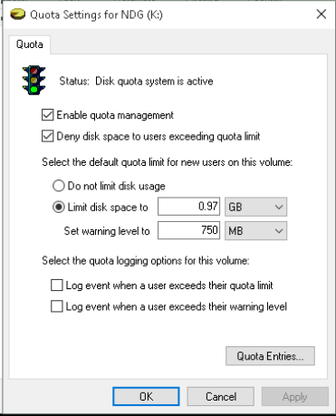

10.2 Quota

10.8 Change Drive Letter

10.9 Delete Partition